Course Name: | EEEE | Semester: | I/II
Date of Performance: | 14/12/21 | Batch No: | A2
Faculty Name: | Maruti Zalte | Roll No: | 16010121045
Faculty Sign & Date: |  | Grade/Marks:

Experiment No: 6
Title: Zener diode voltage regulator

Aim and Objective of the Experiment:
- To understand the working of Zener diode as voltage regulator
- To calculate line and load regulation of Zener diode based shunt regulator

Requirements:
Zener diode, resistor, potentiometer, voltmeter, ammeter, DC source and bread board.

Theory:
A Zener diode functions as an ordinary diode when it is forward biased. It is a specially
designed device to operate in the reverse bias. When it is in the reverse breakdown region, the voltage (V_{z}) across Zener diode remains almost constant irrespective of the current (I_{z}) flowing through it. A series resistor A series resistor Rs is used to limit the zener current below its maximum current rating. The current through Rs is given by the expression is I_{S}=I_{Z}+I_{L} , where I_{L} is the current through the load resistor . The value of Rs must be properly selected to ensure break down of the Zener diode and also to keep Iz in limited in specified current limit.
Rs_{min}= (V_{in}-V_{z})/Iz_{max} (1)
Rs_{max}= (V_{in}-V_{z})/(Iz_{min} + I_{L}) (2)
Design steps:
1. If for regulator
Desired output parameters Vo=5.6 V, I_{Lmax}= 5mA
Input voltage in the range V_{IN} = 8 V- 14 V
2. Choose Zener diode (5.6 V, 45 mA)
3. Choose potentiometer of value 4.7 kΩ so that I_{L} can be varied from 5.6/4.7 kΩ ≈ 1.2 mA.
4. I_{Zmax} = 45 mA so I_{Zmin} = 10% of I_{Zmax} = 4.5 mA
5. R_{Smax} = (V_{INmin} - V_{Z}) /(I_{Zmin} +I_{Lmax}) =(8-5.6) V/(4.5+ 5.0) mA ≈ 253 Ω
R_{Smin} = (V_{INmax} - V_{Z}) / I_{Zmax} = (14-5.6)V/(45 mA) ≈ 186 Ω
Choose R_{Smin} < Rs <R_{Smax} so Rs = 220 Ω and Power rating (I_{max})² x R_{S}
I_{max} = (V_{IN} - V_{Z} )/ Rs = (14-5.6) / 220 = 38 mA
Power rating = (38 mA)² x220 = 0.32 watt ≈ 0.5 watts.

Circuit Diagram/ Block Diagram:
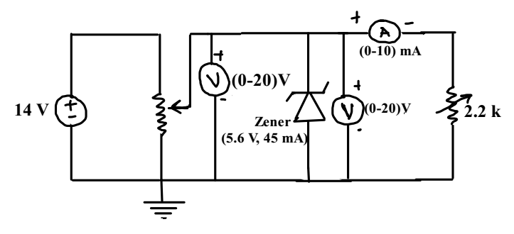

Stepwise-Procedure:
- Design circuit and connect it as shown in the circuit diagram using Proteus simulator.
- Keep V_{IN} more than 8V and adjust Potentiometer R_{L} such that I_{L}= 5 mA. Vary V_{IN} and Note V_{O} for finding line regulation.
- Keep V_{IN} = 10 V and vary Potentiometer R_{L} such that I_{L} changed from 0 to 5 mA and not V_{O} for finding load regulation.
- Plot the graph V_{o} Vs V_{IN} for line regulation and V_{o} Vs I_{L} for load regulation.

Proteus Screen shots
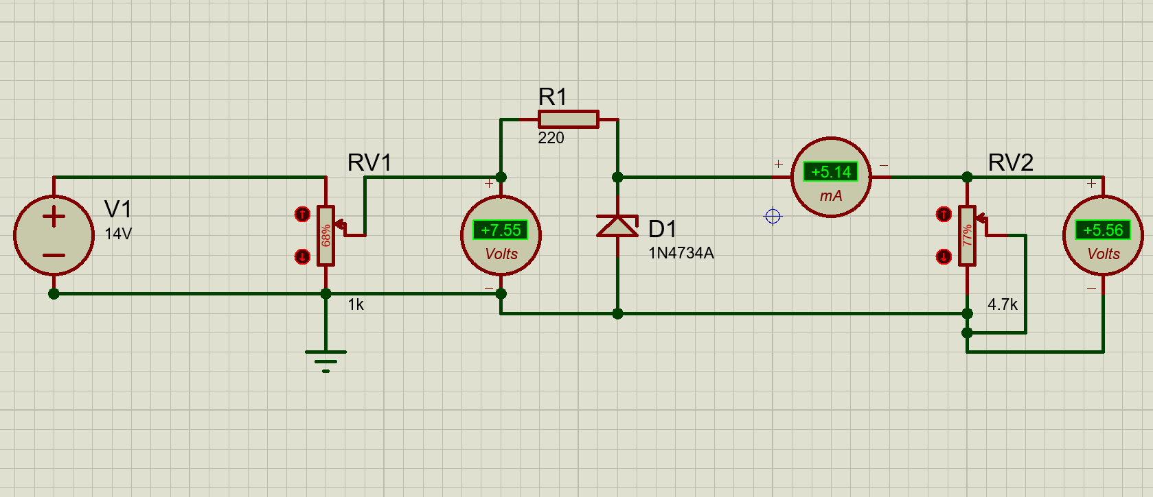
Pargat Singh
Figure 1

Observation Table:
Line Regulation: Set I_{L}= 5 mA Load Regulations: Set V_{IN}= 10 V
V_{IN} (V) | Vo (V) |  | I_{L} (mA) | Vo (V)
4 | 3.37 |  | 1.21 | 5.67
5 | 4.21 |  | 2 | 5.67
6 | 5.08 |  | 3 | 5.66
7 | 5.53 |  | 4 | 5.66
8 | 5.58 |  | 5 | 5.65
9 | 5.62 |  | 6 | 5.64
10 | 5.65 |  | 8 | 5.63
11 | 5.67 |  | 10 | 5.62
12 | 5.70 |  | 12 | 5.6
13 | 5.73 |  | 14 | 5.58
14 | 5.75 |  | 20 | 5.52
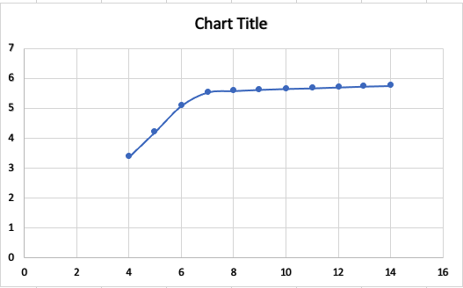
V_{IN}
V_{O}

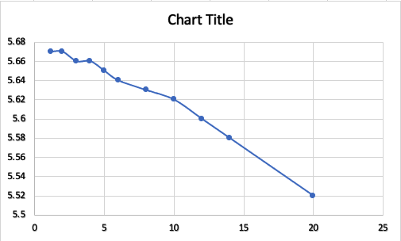
V_{O}
I_{L}

Line regulation= (Δ V_{out} / Δ V_{in} ) x 100
=(5.75-5.53)/(14-7) x 100
=0.22/7 x 100
=3.14 %

Load Regulation=(( V_{NL}-V_{FL})/V_{FL}) x 100’
=(5.67-5.56)/5.56 x 100
=1.98 %
Post Lab Subjective/Objective type Questions:
1. Draw and explain I-V characteristics of Zener diode.
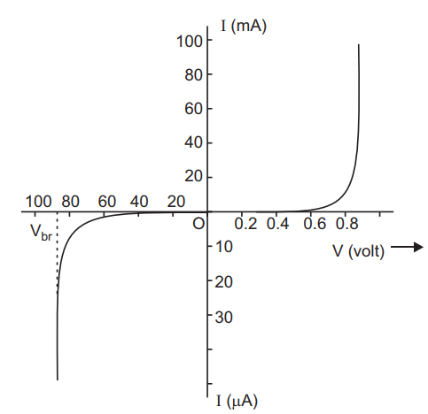
Forward Characteristics
The forward characteristics of a Zener diode is shown in figure. It is almost identical to the forward characteristics of a P-N junction diode.
Reverse Characteristics
As we increase the reverse voltage, initially a small reverse saturation current Io. This current flows due to the thermally generated minority carriers. At a certain value of reverse voltage, the reverse current will increase suddenly and sharply . This is an indication that the breakdown has occurred. This breakdown voltage is called as Zener breakdown voltage or Zener voltage and it is denoted by V_{br}.

2. What is difference between PN junction diode and Zener diode?
The diffrences are as follows:
- The PN junction diode allows the flow of electron in one direction only, whereas the Zener diode allows the flow of electron in both directions.
- The voltage of the PN junction diode at which it starts working is comparatively higher, and the voltage of the Zener diode at which it starts working is lower, and it is known as Zener voltage.
- The PN junction diode is not highly doped. On the other hand, the Zener diode has highly doped junctions.
- On applying a large reverse bias voltage, the PN junction diode has chances of getting damaged, but the Zener diode is specialized for this case.
- PN junction diode is used as voltage rectifiers, switchers, waveshapes, etc., whereas Zener diode is used as voltage stabilizers.

Conclusion:
By performing this experiment and by the graphs plotted we can conclude that when the diode is in the reverse breakdown region, the voltage across Zener diode remains almost constant irrespective of the current flowing through it.

Signature of faculty in-charge with Date:

